Supporting Evidence to the Report ‘Scientific Expert Report on the COVID-19 Epidemic Response in Ireland’
June 2021

The following provides supporting evidence and supplementary evidence for the ‘Scientific Expert Report on the COVID-19 Epidemic Response in Ireland’ by Jay Bhattacharya, MD, PhD and Professor of Medicine in Stanford University, USA. Approximately 33% of this Report.
Dr. Dolores Cahill, Professor of Science and Immunology, UCD. Immunologist.
Dr. Anne McCloskey, medical doctor
Dr. Patrick Morrissey, medical doctor
Mr. Edward Shanahan, Barrister in Ireland and author of Section U of this paper with assistance from David Egan MSc (NUI Galway and University of Oxford)

Supporting Evidence to the Report ‘Scientific Expert Report on the COVID-19 Epidemic Response in Ireland’
We refer courts and tribunals and governments and the general public to the following supporting and corroborating evidence:
- The Investigative Corona Committee Germany in Germany has compiled scientific reports from top scientists, medical doctors, professors and epidemiologists and expert legal reports from layers in relation to
- covid19, its Infection Fatality Rate, Hospitalization rate, Prior Immunity to covid19, Median Age of Death, Excess Mortality, Antibody studies, Deaths in Care Homes.
- ineffectiveness of defective PCR tests for covid19 with high rates of false positives for covid19
- ineffectiveness of lockdowns
- effective medicines for covid19 since March 2020
- ineffectiveness of masks
- the dangers and risks of covid19 vaccines
- the failure of the Imperial College London model used by the British government and Irish government
Scientific and medical reports and scientific findings about covid19 and related matters - https://corona-ausschuss.de/en/documents/
These are to be used in court cases in Germany and other countries. Web site containing scientific and legal reports, scientific and legal interviews about covid19 - https://corona-ausschuss.de/en/
- Mr. Reiner Fuellmich a German lawyer is bringing criminal cases in Germany against the German health authorities and government and some scientists over their response to covid19. He is citing the defective PCR tests which are 97% false positive for covid19. He has gathered evidence from hundreds of medical doctors, scientists, professors, nurses and medical professionals and whistleblowers inside government bodies. He is also trying to bring a case to the international criminal court for crimes against humanity, a Nuremburg II type tribunal.
Sources: https://www.fuellmich.com/ and https://yandex.com/search/?text=REINER%20FUELLMICH%20covid&lr=10426 and https://duckduckgo.com/?q=REINER+FUELLMICH+covid&t=hc&va=u&ia=web

PCR Tests for Covid19
- In May 2021, Sweden announced that PCR tests for covid19 are unreliable and cannot be used for diagnosis. This has been confirmed in news reports in the mainstream press and media. See links below
https://streetloc.com/news/view/7aj/sweden-stops-using-pcr-tests--rna-from-viruses-can-be-detected-for
https://duckduckgo.com/?q=sweden+pcr+tests&t=hc&va=u&ia=web
https://yandex.com/search/?text=sweden%20pcr%20tests&lr=10426

Covid19 Vaccines and Safety Concerns in 2021
- The deaths from covid19 vaccines is much higher than deaths from other vaccines over the previous 30 years according to an official US government source, the VAERS system in the USA. See graph below. This is causing concern in the USA and worldwide. It should be noted that the VAERS system identifies 1 – 13 % of vaccine deaths, injuries, side effects and new illnesses according to a Harvard Medical School study in 2010.

' Adverse events from drugs and vaccines are common, but underreported. Although 25% of ambulatory patients experience an adverse drug event, less than 0.3% of all adverse drug events and 1 - 13% of serious events are reported to the Food and Drug Administration (FDA). Likewise, fewer than 1% of vaccine adverse events are reported. Low reporting rates preclude or slow the identification of “problem” drugs and vaccines that endanger public health. New surveillance methods for drug and vaccine adverse effects are needed.'
Source: Electronic Support for Public Health–Vaccine Adverse Event Reporting System (ESP:VAERS) and https://digital.ahrq.gov/ahrq-funded-projects/electronic-support-public-health-vaccine-adverse-event-reporting-system/final-report

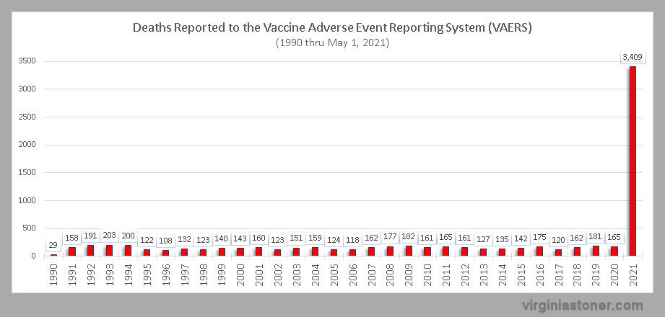

The number of deaths is much higher in 2021 than previous years but even these numbers are an underestimate and may be 10 times higher according to this study by Harvard Medical School in 2010.

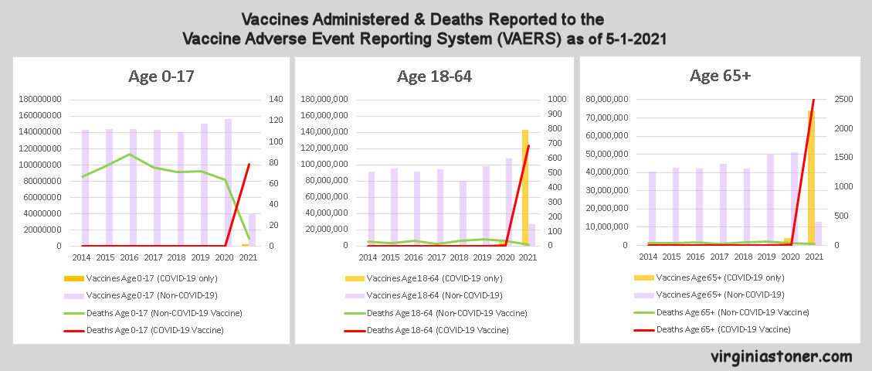

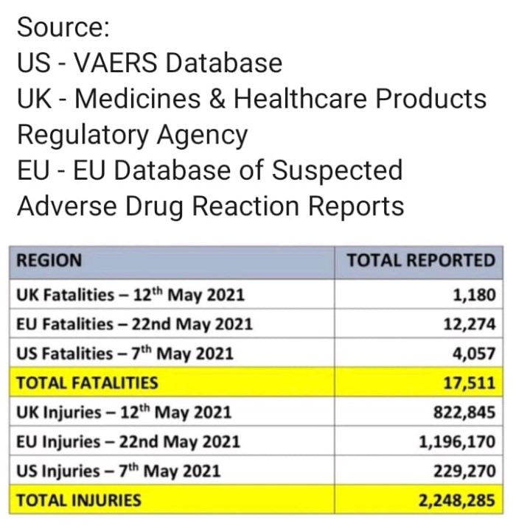

Deaths from the covid19 vaccines
Deaths from the covid19 vaccines are being tracked by official government bodies in several countries, and correlations between covid19 vaccinations and the development of new variants of covid19 are also being tracked. These findings are presented on www.data-analytica.org/page2.htm

The covid19 vaccines cause the body to mass produce dangerous spike proteins
- The covid19 vaccines cause the body to mass produce spike proteins. There is medical and scientific evidence that the spike proteins accumulate in most of the organs in the body and this can seriously injure, damage, disable and kill people. A post mortem found the spike protein in every organ of the vaccinated person's body and inflammatory damage. Paper below.
First case of postmortem study in a patient vaccinated against SARS-CoV-2
Hansen T, Titze U, Kulamadayil-Heidenreich NSA, et al.
Int J Infect Dis. 2021;107:172-175. doi:10.1016/j.ijid.2021.04.053
News Report - First Autopsy of COVID Vaccinated Patient Finds Every Organ of Body Infested with Spike Proteins
- Dr. Mercola, a well known medical doctor and researcher and author in the USA summarises the scientific and medical findings about the spike protein. The covid19 vaccines cause the human body to mass produce these spike proteins.
Effects of covid19 vaccines stimulating spike protein production in the human body
- Scientists and the inventor of mRNA vaccine technology discuss the scientific evidence of the dangers of these Spike Proteins and the risks to human health and human life. See the discussion in the video at https://www.bitchute.com/video/vy2WVSRwGZMo/
- Dr. Peter McCullough a medical doctor and Professor of Medicine in Texas A and M University and a published scientist who is well known and respected in the USA outlines the scientific and medical evidence about the dangers of the covid19 vaccines and spike proteins in this video interview in May 2021 - https://vimeo.com/553518199
- The prestigious Salk Institute has published a scientific research paper outlining the dangers of the spike protein in 2021 - https://www.salk.edu/news-release/the-novel-coronavirus-spike-protein-plays-additional-key-role-in-illness/
- Dr. Michael Yeadon who was chief scientist and vice president of Pfizer and helped develop vaccines and medicines in the past exposes the scientific evidence about covid19 vaccines which promote production of spike proteins
https://thehighwire.com/videos/episode-219-in-harms-way/ and https://www.bitchute.com/search/?query=dr.%20mike%20yeadon%20vaccine&kind=video&sort=new
- More information is being included about these spike proteins on www.data-analytica.org/page2.htm
- India and the "Indian Variant" in 2021
Covid19 deaths rose massively after the covid vaccinations were rolled out in India. Before the covid vaccinations, the covid19 death rate was falling in India. The so called "Indian variant" only appeared after the covid vaccinations. See charts below.

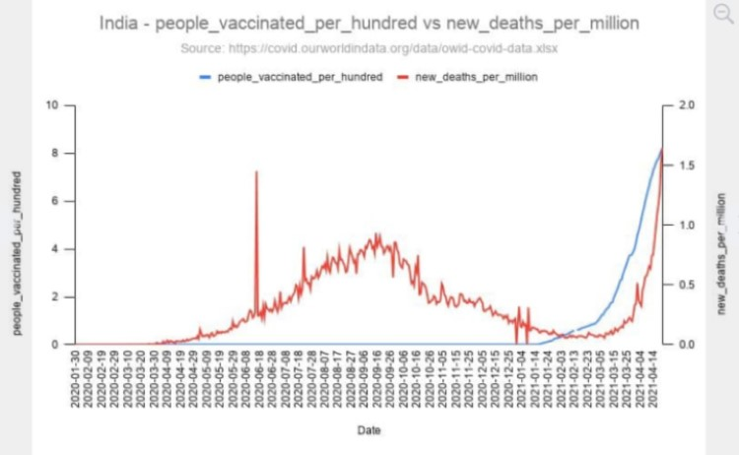
Deaths from new variants of covid19 / vaccinations after covid19 vaccinations
Before the covid19 vaccinations, the death rate was falling. Is this a “Paraguay variant” or is it a variant caused by vaccination ?
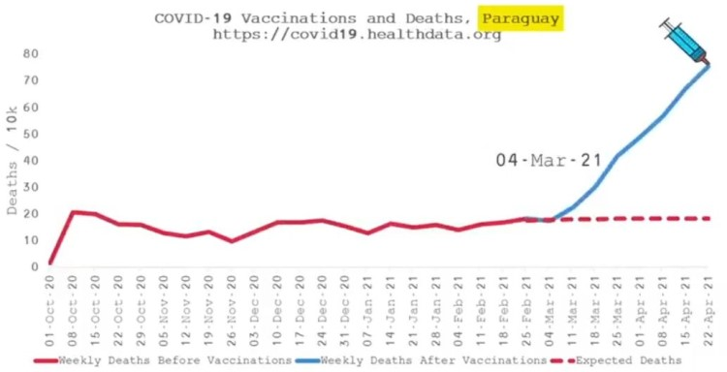
Is this a “Brazilian variant” or is it a variant caused by vaccination ?
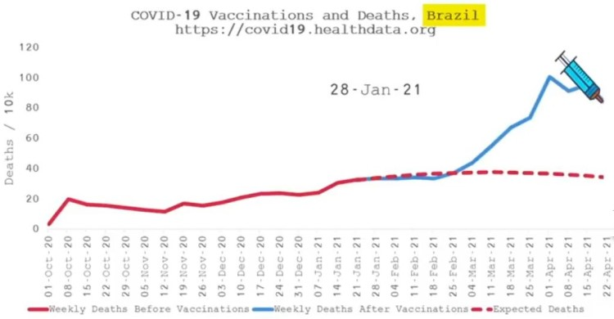
Is this a “Colombian variant” or is it a variant caused by vaccination ?
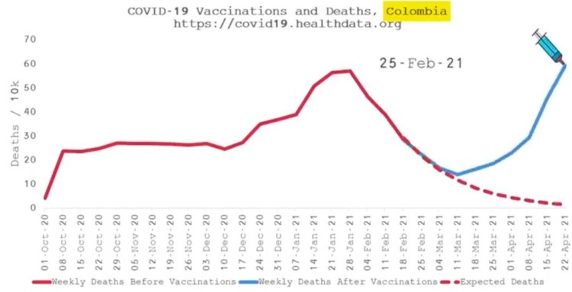
Is this a “Polish variant” or is it a variant caused by vaccination ? 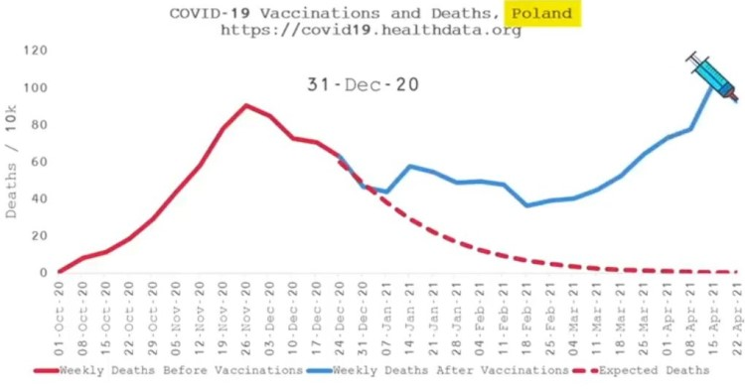
Is this a “French variant” or is it a variant caused by vaccination ?
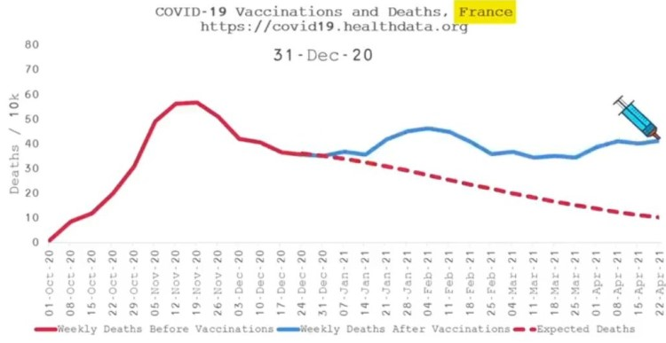

Is this a “Hungarian variant” or is it a variant caused by vaccination ?
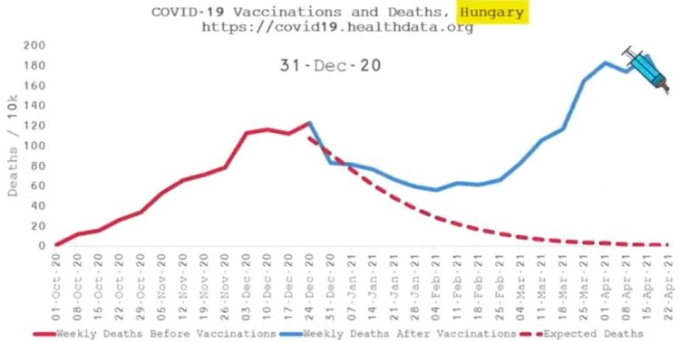
Is this a “British variant” or is it a variant caused by vaccination ?
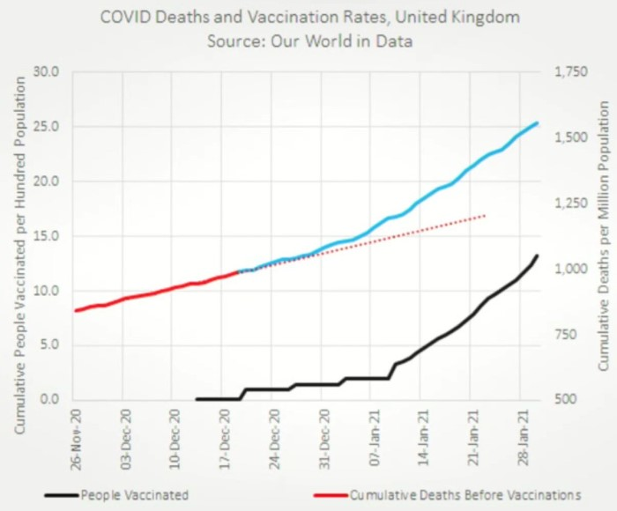

The Relationship between covid19 vaccinations and the incubation and spread of new variants of covid19 in vaccinated people
Dr. Geert Vanden Bossche, a Belgian scientist who was involved in vaccine development and scientific trials for many years has come out publicly against the covid19 vaccines as he believes that they are unsafe and mostly ineffective against covid19. The covid vaccinations may be incubating newer variants of the covid19 in vaccinated people and this is contributing to rising death rates from the covid19 variants. He is calling for all vaccinated people to be regularly tested to identify the covid19 variants they are carrying and spreading. He also is demanding tests to identify all of the new illnesses caused by the covid vaccines and spike proteins. Click on link - https://www.bitchute.com/video/2DlcwDRrl7Uf/

Police Investigation in Britain
- A DVD is attached showing a retired police man Mark Sexton making a statement to police in Britain regarding deaths to over one thousand people and injuries to hundreds of thousands of people in Britain from the covid19 vaccines. Evidence has been handed over to the police. A criminal case and investigation has started in Britain. The video is also available on the internet at https://www.bitchute.com/video/lw7R9Q4OKOjY/ The same vaccine deaths and injuries to thousands of people are occurring in Ireland. This is also the subject of a criminal investigation in Ireland.

T cell Immunity and Memory against covid19 and coronaviruses
- SARS-CoV-2 Human T cell Epitopes: adaptive immune response against COVID-19.
Alba Grifoni, John Sidney, Randi Vita, Bjoern Peters, Shane Crotty, Daniela Weiskopf, Alessandro Sette, ,
Cell Host & Microbe, 2021.
Damage caused by Lockdowns

- Devastating impact of lockdown laid bare in shocking impact report
The Express Britain, June 12, 2021
https://www.express.co.uk/news/uk/1449059/lockdown-britain-impact-report-public-health
‘ Professionals in different fields describe how the shutdown of the country may be responsible for a surge in cancer deaths and mental health distress, and detail the impact of the anti-pandemic measures on the economy and everyday freedoms. The publication of the report, The People’s Lockdown Inquiry, commissioned by the Reclaim Party, comes ahead of the announcement expected on Monday on whether the remaining lockdown restrictions in England will be lifted.’

Excess Mortality in 2020 and 2021
- An important scientific study covering many countries in 2021 revealed that excess mortality was far less than covid19 mortality. Kalinsky and Kobak’s findings indicate that excess deaths has become untethered from official COVID-19 deaths in Europe, and the latter measure is now substantially overstating the pandemic’s death toll. Paper below.
The World Mortality Dataset: Tracking excess mortality across countries during the COVID-19 pandemic by Ariel Karlinsky and Dmitry Kobak, June 2021
medRxiv 2021.01.27.21250604; doi: https://doi.org/10.1101/2021.01.27.21250604
https://www.medrxiv.org/content/10.1101/2021.01.27.21250604v3
News articles
https://noahcarl.substack.com/p/different-ways-of-counting-covid
https://noahcarl.substack.com/p/how-many-excess-deaths-were-there

- Age Specific Excess Mortality is the best measure of Excess Mortality in Ireland and other countries. For example the age groups 90 – 100, 80 – 90 and 70-80 have higher excess mortality due to age and illness related factors, while age groups 60 -70, 50 – 60 etc. etc. have lower excess mortality.
After filtering out false positives for covid19 and the mislabeling of many illnesses as ‘covid19’ in 2020 and 2021, the reduced numbers should have been analysed via Age Specific Excess Mortality. The Age Specific Excess Mortality should have been used in 2020 and 2021 to determine the exact effects of covid19 and compare it to previous years. This would have enabled an accurate comparison to be made between 2020 / 2021 and previous years and decades and accurately assess the impact of covid19.
Deaths in Nursing Homes in 2020 and 2021

Coroners call for statutory inquiry into Covid-19 nursing home deaths
Irish Examiner, 10 June, 2021, https://www.irishexaminer.com/news/arid-40310123.html
There are suspicions by many relatives of the dead that nursing home residents were misdiagnosed with covid19, mistreated, denied medicines for covid19 and subjected to untested, experimental covid19 vaccines in 2021 which have been proven to have dangerous side effects.

Our Covid statistics don’t show whether the virus was the main cause of death
Irish Independent, May 23 2021, https://www.independent.ie/world-news/coronavirus/our-covid-statistics-dont-show-whether-the-virus-was-the-main-cause-of-death-40457539.html

The Leaked Fauci Emails in the USA

The Fauci emails in the USA which are the subject US Congress inquiries and hearings, FBI investigations, police investigations, US military, CIA and NSA investigations, upcoming court cases and tribunals there and elsewhere show that Mr. Tony Fauci head of the NIH in the USA knew in March – July 2020

that masks were ineffective and useless. Yet he publicly supported the use of masks when he was on television and on the press and media.

that ventilators were killing over 90% of covid19 patients in hospitals and that oxygen therapy was safer and more effective in hospitals. He failed to take action on this from March to July 2020

the origins of the covid19 virus in a lab in Wuhan in China and the denials of this

that the NIH in the USA had funded gain of function for coronaviruses in North Carolina in the USA and in a lab in Wuhan in China via the EcoHealth Alliance run by Peter Daszak prior to 2020. And that great efforts were made to conceal this fact in 2020 during the covid19 pandemic

he supported a paper submitted to the Lancet by some scientists organized by Peter Daszak in 2020 refuting all claims that covid19 came from a lab in Wuhan in China. Conflicts of interest involving Peter Daszak and other authors were ignored. This paper may be retracted due to these conflicts of interest, and errors and omissions.

Peter Daszak was part of a WHO team sent to China in 2021 to investigate allegations of a leak from a lab in Wuhan in China causing the covid19 pandemic. They found nothing. Conflicts of interest involving Peter Daszak were ignored.

he acknowledged the infection fatality rate (IFR) was approximately 0.5% and was equivalent to a bad flu season. And the CDC itself stated that the IFR was 0.26% in June 2020 and was equivalent to a bad flu season. Mr. Fauci was aware of the 0.26% figure by June 2021. These facts meant that lockdowns were unnecessary from June 2021. These facts were concealed from the general public and were NOT integrated into US government policies in Summer 2020. The mainstream press and media in the USA and Ireland refused to report this.

he refused to support the use of hydroxychloroquine in 2020 despite the fact that he fully supported its use for SARS which is closely related to covid19 in 2005. He knew that hydroxychloroquine was effective for coronaviruses and for covid19 but he denied this in public.

he refused to support the use of several effective medicines for covid19 in 2020 such as hydroxychloroquine, azt and zinc, Ivermectin, Budenoside, Dexamethasone, Oxygen therapy, Hypoxia treatment, Vitamin D, and plasma antibodies in 2020 but he fully supported experimental covid19 vaccines in 2021. Many medical doctors were prevented from administering effective medicines for covid19 in the USA in 2020. Threats were used against medical doctors by medical bodies which took their advice and guidance from Fauci and the NIH.

Fauci supported lockdowns despite mounting scientific evidence of their ineffectiveness

In 2021 he supported the covid19 vaccines and he has not made any public statements about the relatively high number of deaths and injuries and new illnesses caused by the vaccines. Fauci and the NIH have refused to take actions to resolve this issue despite having a legal duty to do so.

he coordinated with WHO in most of the above. The WHO and Fauci had a major influence on NPHET policies and recommendations in Ireland and on Irish government policies and laws and Irish Medical Council regulations. The same is true for many other countries around the world.

Many people have died in Ireland as a result of the above including the refusal of effective covid19 treatments to patients AND from lockdowns and the cancellations of thousands of hospital appointments for cancers, heart diseases and other non covid19 illnesses in 2020 and 2021. Medical doctors and medical professionals in Ireland and other countries have lost jobs and been threatened with being struck off as a result of this. And Irish businesses have lost billions of euros because of this.

These activities by Fauci had adverse effects on Ireland in 2020 and 2021. The Fauci emails can be viewed or downloaded on https://thehighwire.com

The Ineffectiveness and Dangers of Masks

New scientific research has revealed that masks contain many dangerous forms of bacteria and viruses which can illnesses in humans and seriously harm humans, including children. See https://alachuachronicle.com/dangerous-pathogens-found-on-local-residents-face-masks/

The ineffectiveness and dangers of masks against covid19 and viruses has been analysed in scientific studies listed on https://corona-ausschuss.de/en/documents/

Natural T cell Immunity against covid19 and it’s variants

Scientific research is now revealing that natural t cell immunity is effective against covid19 and it’s variants. There is 0.3% difference between covid19 and its variants and the immune system is capable of recognizing and eliminating variants based on prior recognition of covid19. Scientific paper cited below
Negligible impact of SARS-CoV-2 variants on CD4 ⁺ and CD8 ⁺ T cell reactivity in COVID-19 exposed donors and vaccinees
Tarke A, Sidney J, Methot N, et al. Preprint. bioRxiv. 2021;2021.02.27.433180. Published 2021 Mar 1. doi:10.1101/2021.02.27.433180 https://pubmed.ncbi.nlm.nih.gov/33688655/
The Suppression and Blocking of Effective Medicines for covid19 in 2020 and 2021 and Legal Actions and Court Cases
- Ivermectin has led to a massive reduction in covid19 cases and deaths in several states in India in 2021. Thousands of lives have been saved. Yet the WHO has publicly called for Ivermectin treatment to be stopped. The Indian Ministry of Health has been (illegally) pressurized by WHO to stop the use of Ivermectin in India. This has led to outrage in India as Ivermectin has saved and is saving the lives of thousands of people there. The Indian Bar Association has responded to this interference by WHO and served a legal notice to the chief scientist at the WHO, Dr Soumya Swaminathan, for “influencing the public against” and “running a disinformation campaign against Ivermectin” — a popular anti-parasitic drug prescribed for Covid-19 patients. This will lead to court cases in India if the WHO persists in condemning and blocking this effective medicine. This is in the mainstream news in India. This is a continuation of the WHO policy of blocking and denying cheap, generic and effective medicines for covid19.
Sources: https://theprint.in/india/bar-association-serves-legal-notice-to-who-chief-scientist-over-ivermectin-guidelines/676672/
https://trialsitenews.com/indian-bar-association-serves-legal-notice-upon-dr-soumya-swaminathan-the-chief-scientist-who/
https://yandex.com/search/?text=indian%20bar%20who%20chief%20scientist&lr=10502

- Dr. Peter McCullough a medical doctor and Professor of Medicine in Texas A and M University and a published scientist who is well known and respected in the USA exposes the suppression and blocking of effective medicines for covid19 in 2020 and 2021 in the USA and many other countries including Ireland. This led to many deaths. See his video interview in link below - https://vimeo.com/553518199

Criminal Law and Civil Law Issues :
Medical Negligence and Malpractise as applied to the HSE, Medical Council, NPHET, the CMO and the Minister for Health who guided and/or coerced medical doctors in Ireland in the diagnosis and treatment of and response to covid19 in 2020 and 2021
Medical negligence and malpractise typically involves the following:
- Failure to correctly diagnose or plan to monitor and potentially address a known medical risk for the patient, including cases related to childbirth, disease risks, general health risks, and in light of the context of the patient’s overall health.
  - The scientific and medical evidence now clearly show a high rate of false positives for covid19 as high as 97% in Ireland which meant that most covid19 patients were misdiagnosed and misled. This failure made it impossible to assess medical risk for the patient, including cases related to childbirth, disease risks, general health risks. When these scientific and medical facts were brought to the attention of the HSE and medical and government authorities they ignored them in 2020 and 2021. This failure was a clear breach of the law.
  - The lockdowns enforced by the government on the advice of NPHET, the CMO, the Minister for Health, the HSE and the medical authorities led to the cancellation of thousands of hospital appointments for cancers, heart diseases, diabetes, neurological illnesses, endocrine illnesses, respiratory illnesses, bacterial pneumonia, colds, flu’s, alzheimers, dementia, and many chronic illnesses. This failure made it impossible to assess medical risk for the patient, including cases related to childbirth, disease risks, general health risks. This has led to deaths and will lead to more deaths. When these facts were brought to the attention of the HSE and medical and government authorities they ignored them in 2020 and 2021. This failure was a clear breach of the law and of medical ethics.
- Failure to render appropriate or effective treatment, including prescription drug mistakes that breach a reasonable standard of care per Irish medical negligence case precedents.
  - The deliberate suppression and blocking of hydroxychloroquine, azt and zinc, Ivermectin, Budenoside, Dexamethasone, Oxygen therapy, Hypoxia treatment, Vitamin D, and plasma antibodies for covid19 treatment in 2020 and into 2021. The scientific and medical evidence supported these treatments for covid19 and many doctors around the world got excellent results from the. Some corrupt officials within the WHO and NIH (USA) and some corrupted scientists (with conflicts of interest) misadvised and lied to many governments and NPHET and the CMO about this. This failure to provide effective medicine to patients was a clear breach of the law.
  - The promotion of lies and deception in some medical journals and the press and media to block, stop and prevent hydroxychloroquine in the treatment of covid19 was clearly exposed worldwide in 2020. One paper was retracted from the prestigious Lancet journal in 2020. The use of lies and deception to block effective and important medical treatments for covid19 was one of the most shocking news stories in 2020 and it affected Ireland and the use of hydroxychloroquine by medical doctors and the medical council here. This deprivation of effective medicine was a clear breach of the law.
  - The HSE, the WHO, NPHET, the Minister for Health and the medical council told covid19 patients to self isolate at home and did NOT tell them about or prescribe effective medicines for covid19 in 2020 and 2021. This was a clear breach of the law and of medical guidelines and ethics.
  - The promotion of and use of experimental covid19 vaccines in 2021 which have led to many thousands of deaths worldwide by July 2021 and to hundreds of thousands of injuries, serious disabilities and new illnesses worldwide by July 2021. This has been detailed in the US government VAERS system, the MHRA yellow card system, the EMA monitoring system and on web sites such as https://childrenshealthdefense.org/ and www.data-analytica.org/page2.htm Persons who were vaccinated in Ireland were not warned about the dangers and risks of taking these coivd19 vaccines. This failure to get informed consent was a clear breach of the law.
- Failure to adhere to patient informed consent requirements as the causes of a medically relevant and cost-causing injury to the patient.
  - The promotion of and use of experimental covid19 vaccines in 2021 which have led to many thousands of deaths worldwide by July 2021 and to millions of injuries, serious disabilities and new illnesses worldwide. This has been detailed in the US government VAERS system, the MHRA yellow card system, the EMA monitoring system and on web sites such as https://childrenshealthdefense.org/ and www.data-analytica.org/page2.htm Persons who were vaccinated in Ireland were not warned about the dangers and risks of taking these coivd19 vaccines. This failure to get informed consent was a clear breach of the law.
- Hospital mistakes, including mistakes in anesthesia, medical devices, and instances of gross negligence
  - Evidence has emerged in Ireland and several other countries of covid19 patients being put on ventilators at high pressure which led to their deaths in 2020. Other more effective medical treatments were available and should have been used and these would have saved lives and brought about recoveries.
  - Misdiagnosis due to the high rate of false positives for covid19 led to neglect or lack of treatment for actual illnesses and injuries and over emphasis on covid19. And the suppression and blocking of effective medicines for covid19 in 2020 worsened this scenario for patients. In addition to neglecting the real illnesses (non covid19 illnesses) and injuries of patients.
- Blackmail, Threats and Extortion against medical doctors who tried to use effective medicines for covid19 in 2020 and 2021 by state officials and officials from medical authorities. Medical doctors were threatened with loss of jobs, positions, and their medical career in 2020 and 2021. High ranking officials misused their position and authority to bully threaten, blackmail and extort medical doctors. This fuelled the blocking and suppression of effective medicines for covid19 in 2020 and 2021. This was and is a breach of the law and of medical guidelines and ethics.
- Blackmail, Threats and Extortion against medical doctors who spoke out publicly against lockdowns after June 2020. Those people with expertise in medicine and science and with evidence and facts were blocked from speaking and exercising their right to free speech and free debate.
- Blackmail, Threats and Extortion against medical doctors and nurses to get the experimental covid19 vaccine or lose their jobs, positions and careers and livelihoods. The same threats are being used against workers in other industries. The vaccines are not fully authorized and safety tested and are experimental and there have been thousands of deaths and millions of injuries and illnesses caused by them. This has been detailed in the US government VAERS system, the MHRA yellow card system, the EMA monitoring system and on web sites such as https://childrenshealthdefense.org/ and www.data-analytica.org/page2.htm. There are dangers involved and forced consent is the opposite of informed consent. This forced consent, Blackmail, Threats and Extortion was and is a breach of the law and of medical guidelines and ethics.
- Failure to provide timely or adequate treatment in a reasonable period, which later harms or is the cause of further medical harms to the patient
  - See sections 1, 2, 3, 4, 5, 6 and 7 above
- Inability to get an accurate diagnosis of covid19 due to the high rate of false positives meant that persons with covid19 infection were allowed to mingle with vulnerable persons in hospitals and nursing homes placing them at risk of infection. This placed lives at risk. And the blocking and suppression of effective medicines for covid19 worsened this situation.
- Neglect of elderly persons in nursing homes and placing them in danger as exposed by doctors and nurses and families in 2020 and detailed on http://www.data-analytica.org/index.htm#nursing clearly shows breaches of the law and breaches of medical guidelines amounting to negligence and malpractise.
- False labeling of the cause of death and the misuse of this to sow public alarm, fear and panic and more lockdowns which undermined medical treatments for other diseases and illnesses and public health in 2020 and 2021 as detailed in sections above
  - The evidence submitted in our Book of Evidence shows that the vast majority of people who died were mislabeled with covid19 due to the high rate of false positives for covid19 and the majority of these persons were elderly and had two or more pre-existing illnesses which were capable of causing death. The average age of death for covid19 was 82 and the median age was 84 and 94% of them had two or more pre-existing illnesses.
  - There was no significant excess mortality for Ireland in 2020 and actual deaths in 2020 were very similar to deaths for the previous seven years.
Medical Doctor calls for the Abolition of NPHET
Dr Vincent Carroll a highly experienced and qualified medical doctor has publicly called for the abolition of NPHET as it is not fit for purpose and has failed the Irish people and nation in 2020 and 2021. Many of his medical doctor friends privately agree with him but they are too intimidated and frightened to publicly admit this. This is due to the level of blackmail and threats against medical doctors, nurses and medical professionals in 2020 and 2021 which is unprecedented and shocking. A link to his Public Announcement is provided below.
www.data-analytica.org/carroll.mp4 or https://www.bitchute.com/video/6SOr5hAlLYoW/ or https://www.youtube.com/watch?v=cgUoG4BZNe4
Seasonality of Viruses including coronaviruses which cause colds and flu’s for many years and decades and covid19 is a coronavirus
- The scientific research and data presented by Dr. Ivor Cummins online clearly shows that covid19 was a seasonal virus comparable to colds and flu’s which are also caused by coronaviruses for many years and decades. See his scientific findings on https://odysee.com/@IvorCummins:f and https://thefatemperor.com/
Dr. Ivor Cummins can be subpoenaed into court to verify all of this.
Delta Variant
- The following video presentation by Dr. Ivor Cummins on June 30th 2021 provides the scientific facts, evidence and statistics about the Delta variant of covid19 in 2021. He can be subpoenaed into courts and tribunals to confirm and verify these scientific findings.
https://www.youtube.com/watch?v=6TR0Nrds16Y and
https://odysee.com/@IvorCummins:f/a-short-crucial-update-on-the-delta:1 also available on https://thefatemperor.com/videos/ and https://www.bitchute.com/video/ayCAKp1Dv9S6
False Statistics Charge
- Covid19 vaccine deaths are not been properly recorded In Ireland. In other countries post mortems of dead covid19 vaccinated people have revealed serious medical injuries and damage such as the spike protein in every organ of the body and accompanying inflammatory damage, blood clots, hemorrhaging, heart attacks, strokes, vascular damage, lung damage, nervous system damage and blindness or deafness. The Irish government needs to mandate post mortems for all covid19 vaccine deaths so as to establish how the vaccine caused these deaths or severe injuries. This will enable the Irish government to attain accurate statistics about deaths, causes of deaths, and causes of serious injuries.
- In June 2021 a court in Lisbon ruled that 99% of covid19 deaths were not covid19. They were deaths from other causes. These people had pre-existing illnesses and co-morbidities and most were elderly. Only 152 deaths out of 17,000 deaths were specifically covid19 and nothing else. The Reports are listed below.
https://andre-dias.net/wp-content/uploads/Fwd-Sentenca.pdf and
on medical doctors web site at https://americasfrontlinedoctors.org/frontlinenews/lisbon-court-rules-only-0-9-of-verified-cases-died-of-covid-numbering-152-not-17000-claimed/
This has serious implications for Ireland and other countries and corroborates the findings of some coroners in Ireland and our Book of Evidence.
- The CDC in USA is being sued by 7 Universities in America. It is being sued for fraud. Not one sample of 1,500 positive covid19 samples of people showed evidence of covid19 infection and presence. Article attached to this Report. More information on the Yandex search engine and Duckduckgo search engine and non Google search engines.
Also download newspaper article on www.data-analytica.org/newspaper.png

